電通二乙微處理器實驗 實驗結報

實驗名稱 | Lab03
組別 |  | 組員 | 03053622 易大閎

- 實驗目的

- 實驗步驟

- 程式碼
Check 1 :

const byte Pin = 13;
byte val;
void setup() {
// put your setup code here, to run once:
Serial.begin(9600);
pinMode(13, OUTPUT);
}

void loop() {
// put your main code here, to run repeatedly:
if(Serial.available()){
val = Serial.read();
if(val=='1'){
digitalWrite(Pin, HIGH);
Serial.println("LED ON");
}
else if (val=='0'){
digitalWrite(Pin, LOW);
Serial.println("LED OFF");
}
}
}

Check 2 :

word Analogin;
float Vin;
void setup() {
Serial.begin(9600);
Analogin = 0;
}

void loop() {
// put your main code here, to run repeatedly:
for (int i=0;i<=5;i++){
Analogin = 0.7* Analogin + 0.3* analogRead(A0);
}
Vin = Analogin * 2.5 / 4095;
Serial.println(Vin);
delay(500);
}

Check 3 :

word Analogin;
float Val;
word sensorValue = 0;
long sensorVoltage;
float R1;
int i;
void setup() {
Serial.begin(9600);
}

void loop() {
for (i=0;i<=5;i++)
sensorValue = 0.7* sensorValue + 0.3* analogRead(A0);
sensorVoltage = sensorValue * 5 / 4095;
R1 = sensorVoltage * 1000000 / 5;

//Output sensorValue, sensorVoltage, and R1 to serial
Serial.println(sensorValue);
Serial.println(sensorVoltage);
Serial.println(R1);
delay(500);
}

- 實驗結果及分析
Check1 :
PC輸入 | SerialMonitor輸出 | LED狀態
0 | 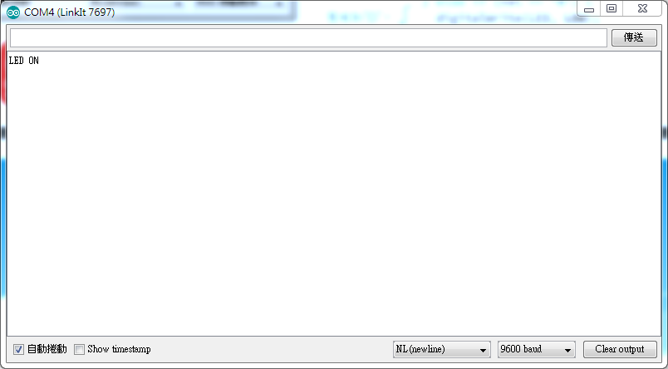 | 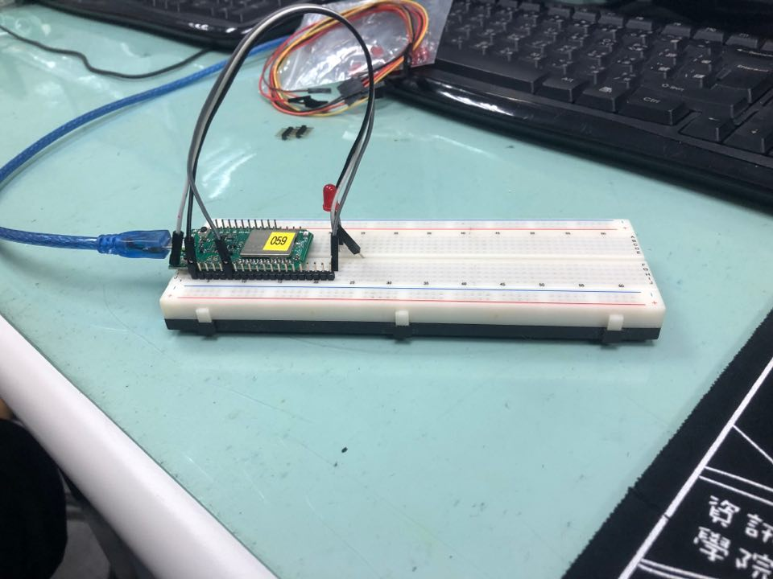
1 | 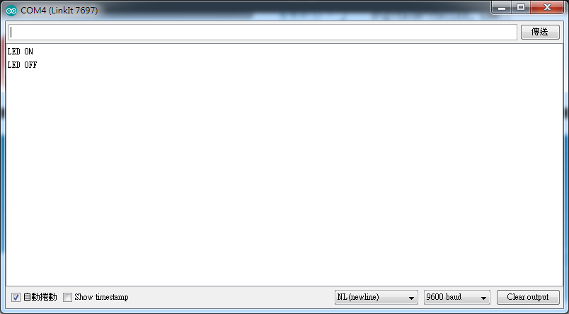 | 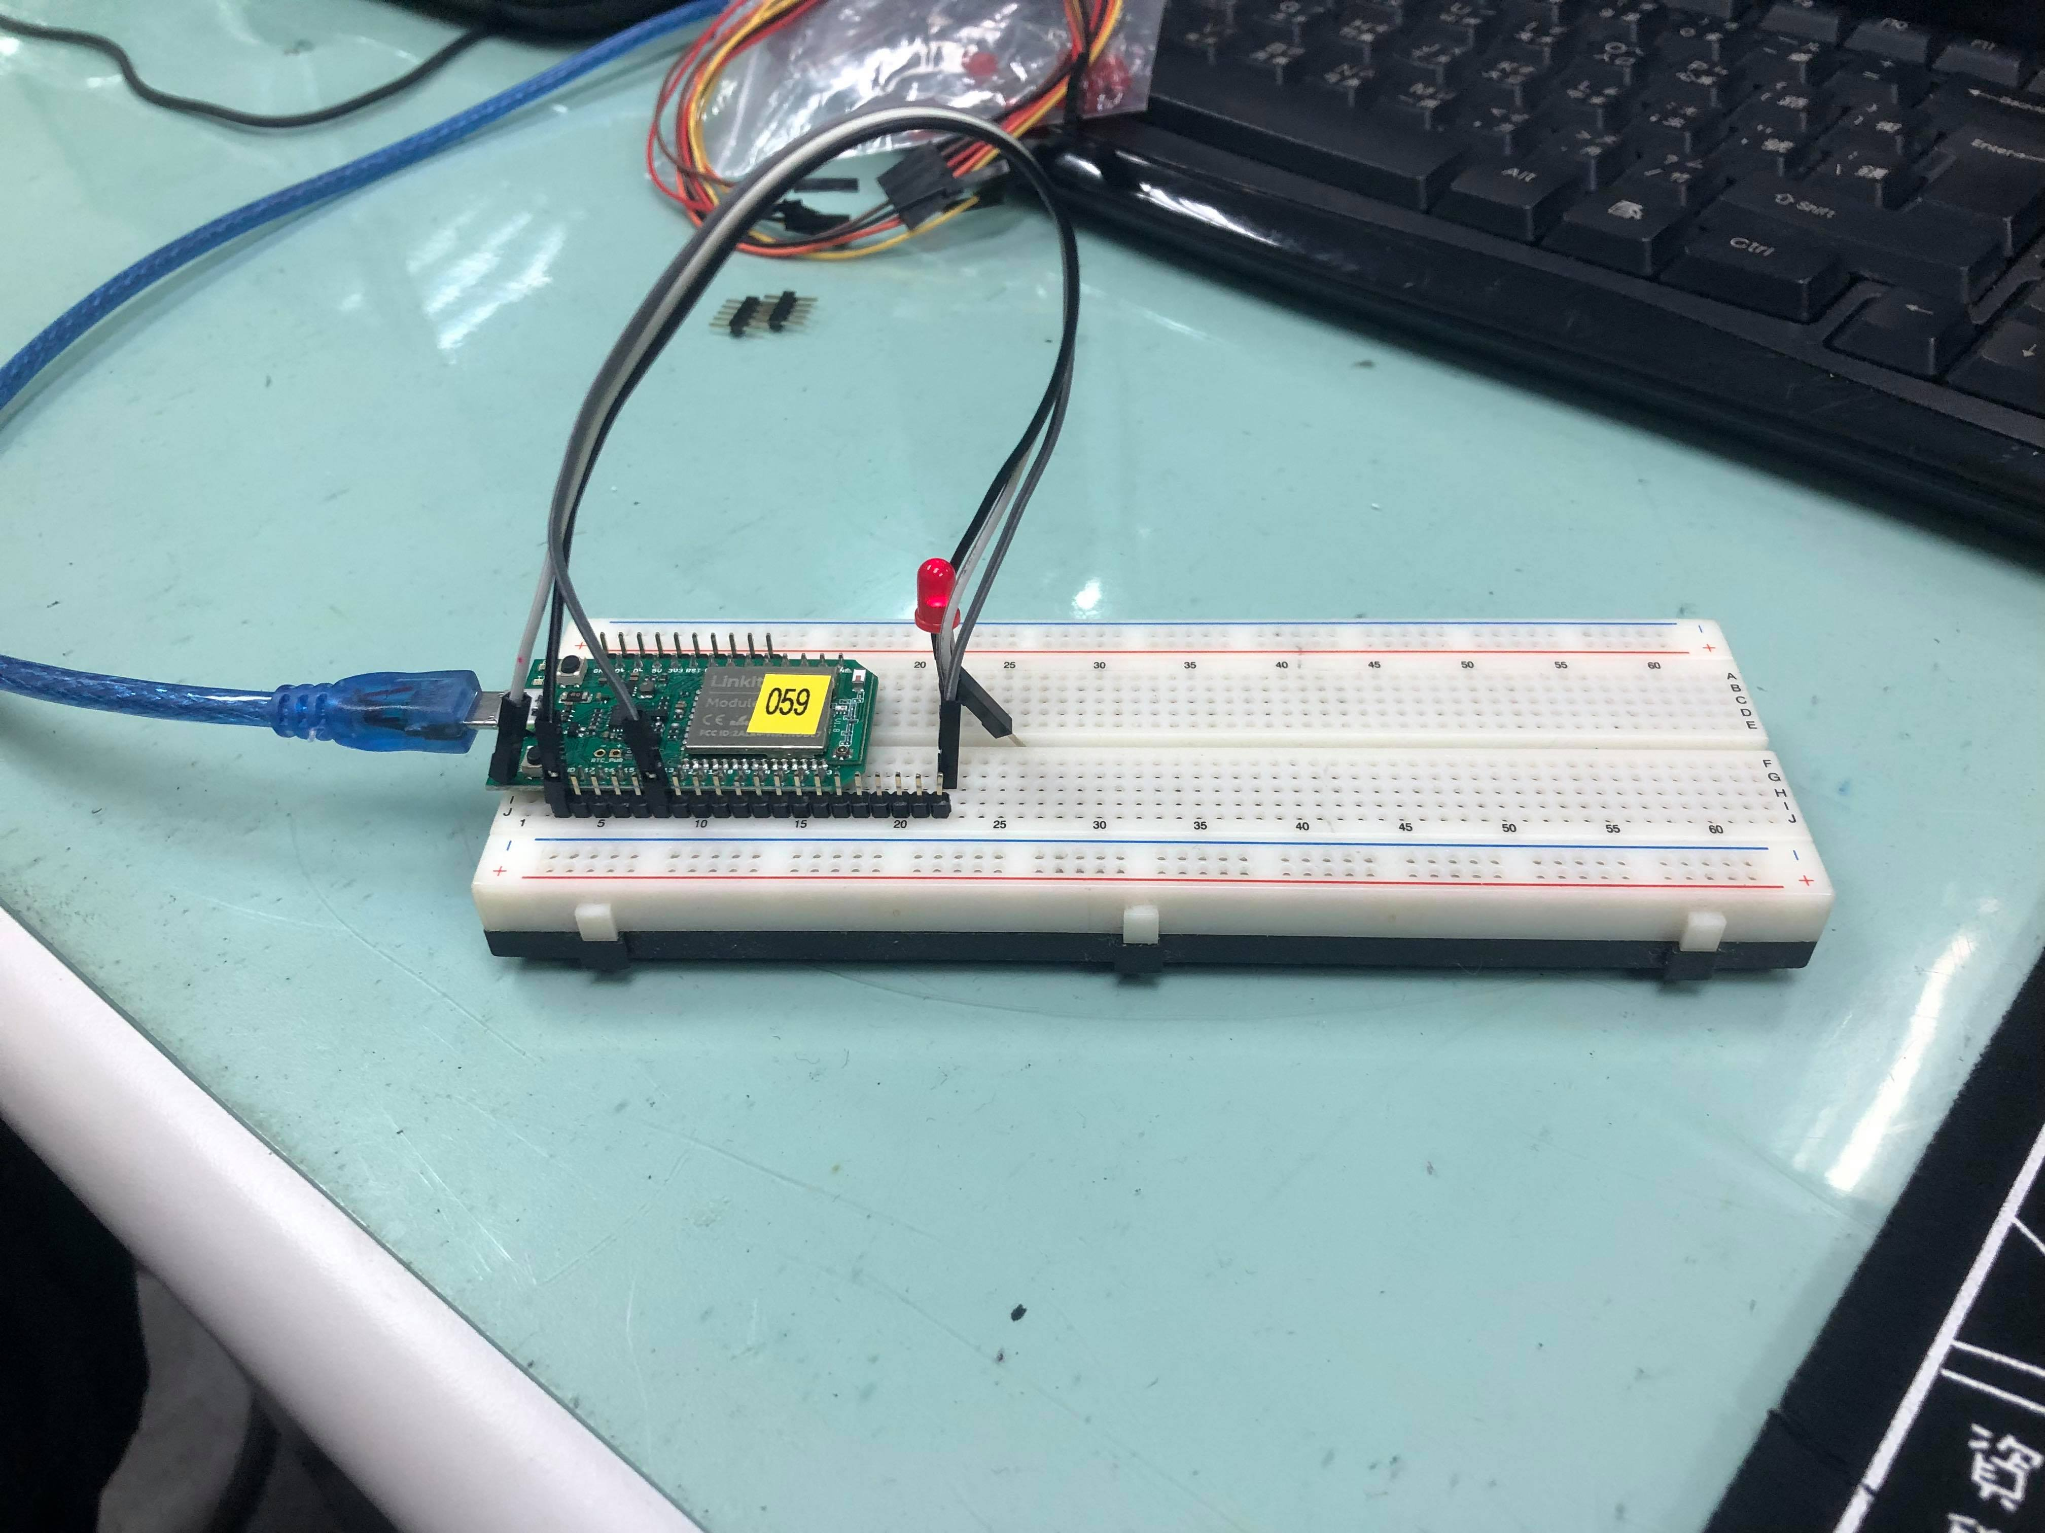

Check2 :
實際電壓(V) | AnalogRead讀值 | 推測電壓(V)
0 | 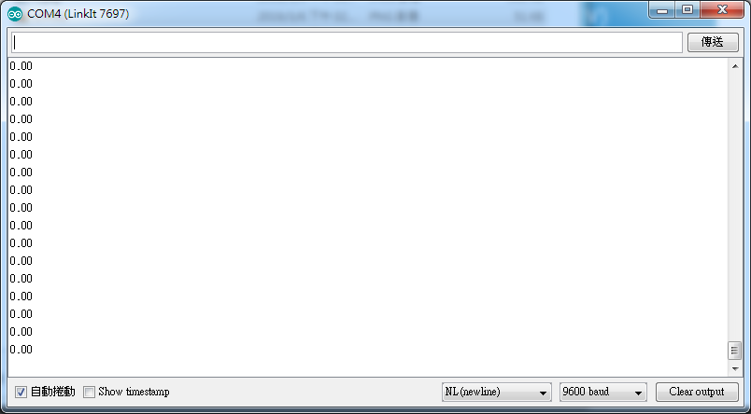 | 0
0.5 | 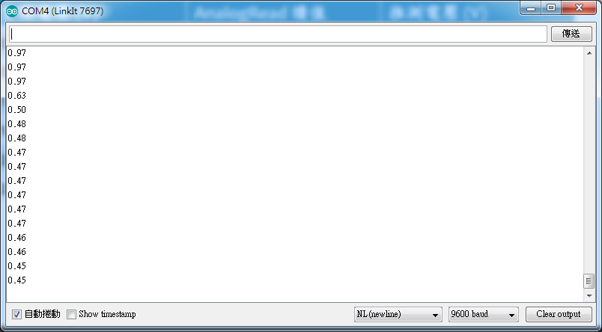 | 0.5
1 | 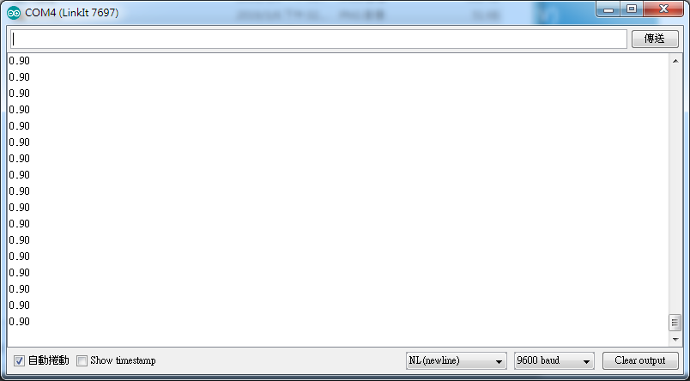 | 1
1.5 | 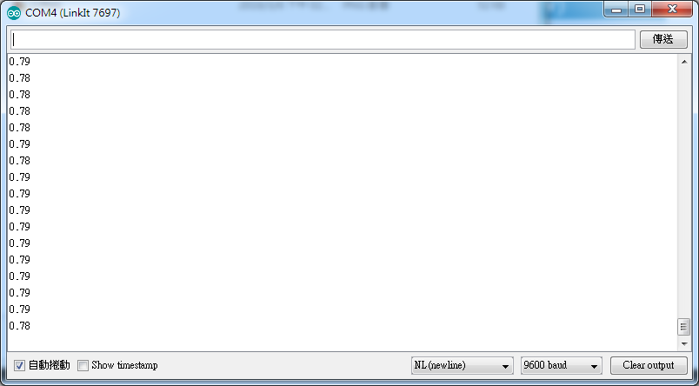 | 1.5
2 | 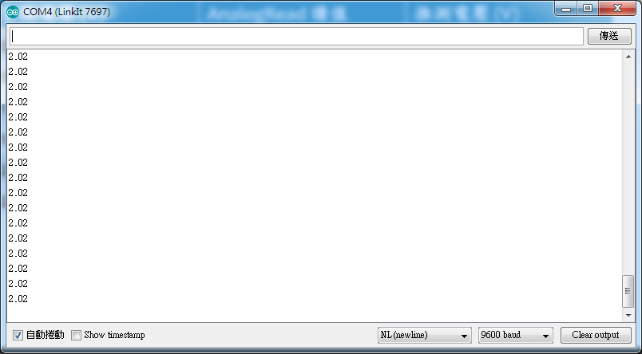 | 2
2.5 | 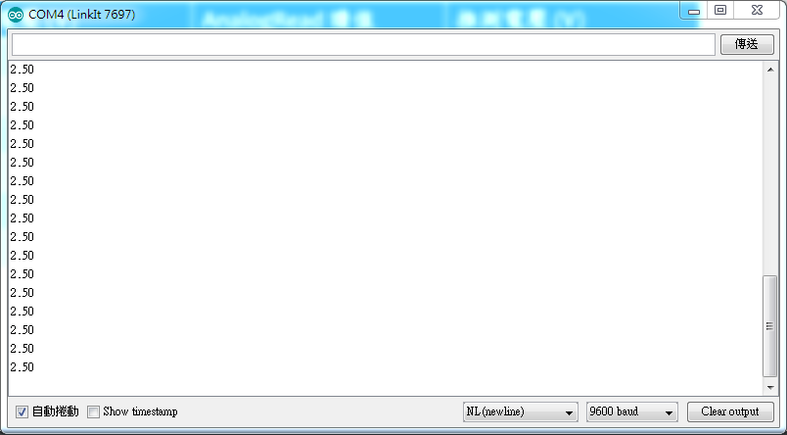 | 2.5

- 心得討論
前兩個挺順利的，第三個做不出來，死去
- 修正電路圖
- 修正程式碼

